|  |  |  |
| --- | --- | --- |
| **Report IDM reference No.** | *EFDA_D_xXXXXX* | **Version: see IDM** |

Final Report

on Deliverable

*Mat-1.3.1-T006-D001 - Creep-Fatigue Rules for EUROFER*

|  |  |  |  |
| --- | --- | --- | --- |
|  | | **Deliverable-ID**[1] | *MAT-1.3.1-T006-D001* |
| **Work Package** | *WPMAT* | **Date** | *31. October 2016* |
| **Project Leader** | *Michael Rieth* | | |
|  | | | |
| **TS Title** | *EDDI Structural Design Criteria – Priority Gaps – Creep-Fatigue* | | |
| **TS Ref. No.** | *MAT-1.3.1-T006* | **TS IDM-link** | [*2MUG9D*](https://idm.euro-fusion.org/?uid=2MUG9D&action=get_document) |
| **Task Owner** | *Jarir Aktaa* | | |
| **RU(s)** | *KIT* | | |

|  |  |
| --- | --- |
| **Report Review & Approval** | |
| **IDM role** | **Name(s)** |
| **Author** | *Jarir Aktaa* |
| **Co-author(s)** |  |
| **Reviewer(s)** | *Michael Gorley* |
| **PMU Reviewer** | *Eberhard Diegele* |
| **Approver** | *Michael Rieth* |

|  |  |  |  |  |  |
| --- | --- | --- | --- | --- | --- |
| x | Study / Assessment |  | Procurement / Commissioning of Hardware |  | Industry |

|  |  |  |  |
| --- | --- | --- | --- |
|  | Use of Facility |  | Other *{please specify}* |

|  |
| --- |
| **Executive Summary** |
| The creep fatigue rules proposed for EUROFER based on proper modifications of the creep-fatigue accumulation rules of the ASME-BVP and RCC-MRx codes are further simplified by introducing the cyclic softening stress factor, $K_{ψ}$ approach easing their implementation in existing design codes. First results of the creep tests on pre-fatigued specimens launched for generating data required for applying the new rules back the approach pursued. |

|  |
| --- |
| **Comments** (shortcomings, deviations, etc.) |
|  |

**Table of Contents**

1 Introduction and Objectives of Work 3

2 Description of Work 3

3 Conclusion 6

4 References 7

**Abbreviations**

|  |  |
| --- | --- |
| ASME-BPV | American Society of Mechanical Engineers – Boiler and Pressure Vessel |
| RCC-MRx | Design and Construction Rules for mechanical components of nuclear installations |

# Introduction and Objectives of Work

The aim of the work is the development of creep-fatigue design rules for the ferritic martensitic steel EUROFER. Cyclic softening of ferritic martensitic steel and its impact on creep strength are identified as the main reason for the strong non-linear creep-fatigue interaction evaluated using conventional creep-fatigue rules. Therefore a modification has been proposed for the creep-fatigue accumulation rule by ASME-BPV and RCC-MRx codes in which the influence of cyclic softening on creep rupture time shall be taken into account. The application of this modification requires creep rupture lifetimes measured in creep tests performed on pre-cycled and thus pre-softened specimens. To provide these additional material design data a test programme was initiated elaborating a proper test matrix [1, 2]. For the verification of the modified rules another test matrix has been proposed including LCF tests with particularly long hold times [3]. Awaiting sufficient test results are available the coupled deformation-damage model developed for EUROFER [4] is used to verify the approach pursued for simplifying the modified rules and hence easing their implementation in existing design codes. In addition, first results of the creep tests on pre-cycled EUROFER specimens performed at 550°C are evaluated.

# Description of Work

Based on the assessment performed in 2014 for the applicability of the creep-fatigue accumulation rules of the ASME-BVP and RCC-MRx codes to 9-Cr steels the following modification of this rules has been proposed [5]:

* Calculation of creep damage portion in the creep fatigue accumulation rule in
  1. first 10% of the lifetime using *Si* from monotonic stress strain curves and design creep curves of as received material assuming no effect of cyclic softening on stress-to-rupture curves
  2. remaining 90% of the lifetime using *Si* from cyclic stress strain curves and design creep curves of cyclic softened material
* Using allowable total creep fatigue damage values of RCC-MRx for SS 316 and Grade 91 - envelope with (0.3,0.3) tip point.

The application of this modification requires among others creep lifetimes determined for EUROFER pre-softened to different cyclic softening levels, $ψ$ [1] whereas $ψ$ is a function of strain amplitude and number of cycles and defined as the strength of softened material at a given strain amplitude divided by that of the un-softened material at the same strain amplitude (s. Figure 1). Having them a cyclic softening stress factor, $K_{ψ}=f(ψ)$ will be then identified as the amplification factor to be applied to the stresses of design creep curves of cyclic softened material in order to be shifted to the design creep curve of as received, cyclic un-softened material (s. Figure 2). With this factor the modified creep-fatigue rules can be easily implemented in design codes by only introducing two calculation steps to the existing rules:

1. Determination of the cyclic softening level 𝜓 for given total strain range and temperature by using monotonic and cyclic stress-strain curves (s. Figure 1).
2. Determination of the cyclic softening stress factor $K_{ψ}$ given as function of 𝜓 and applying it to the stress considered for calculating the respective creep damage. Thereby the allowable creep time is obtained from stress-to-rupture curve of un-softened material at a stress equal to $K_{ψ}∙σ$ (s. Figure 3).

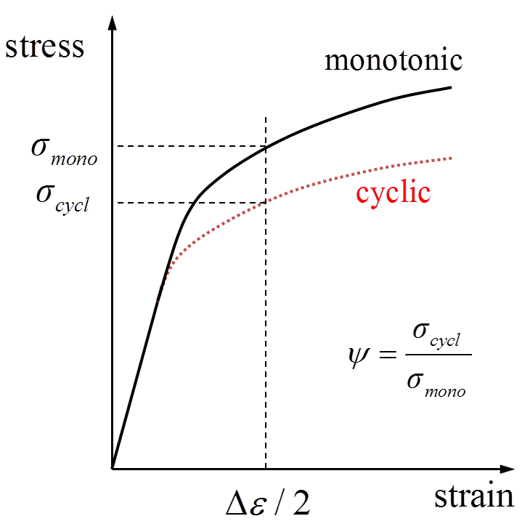

Figure 1:Determination of of the cyclic softening level 𝜓 for given total strain range and temperature.

For obtaining creep lifetimes determined for EUROFER pre-softened to different cyclic softening levels and hence the function $K_{ψ}=f(ψ)$, a test programme was launched for performing creep tests on pre-cycled specimens according to the test matrix specified in [1, 2]. Meanwhile four tests were finished. The evaluation of their results confirms the assumed independence of the Monkman-Grant relationship on pre-cyclic deformation and cyclic softening, respectively [1] (s. Figure 4).

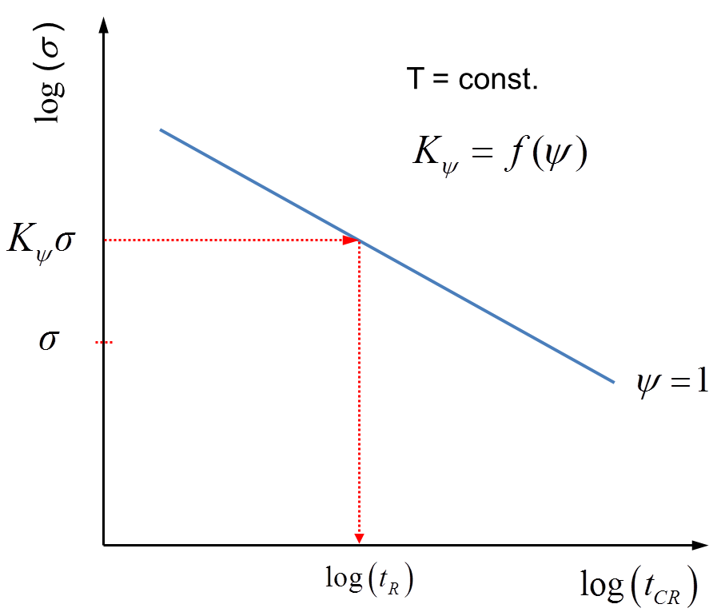

Figure 3: Determination of creep rupture time for given stress, temperature and cyclic softening level using the cyclic softening stress factor, $K_{ψ}$.

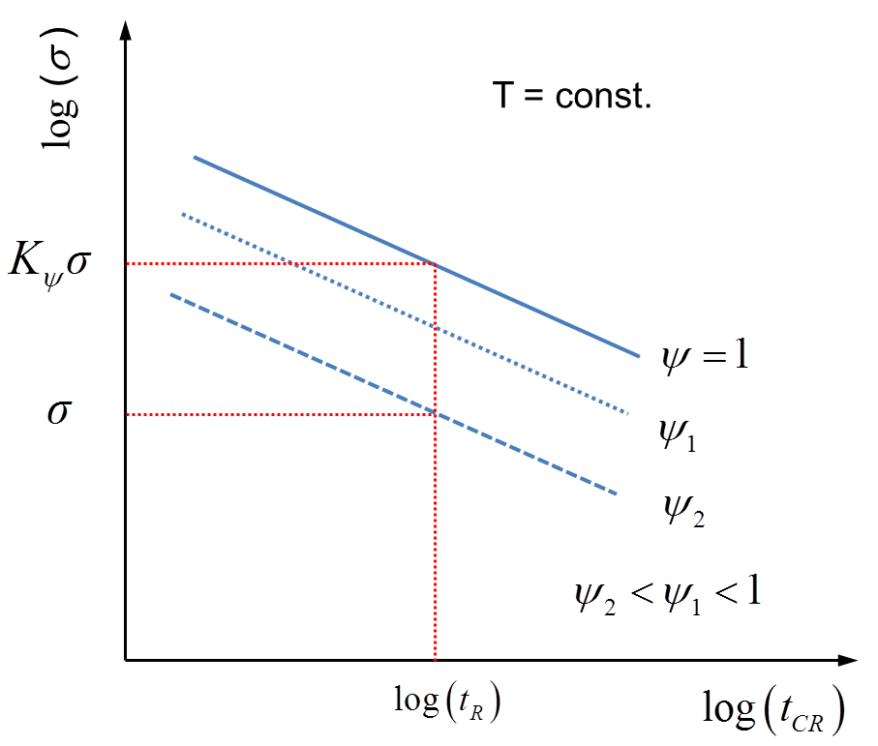

Figure 2: Identification of cyclic softening stress factor, $K_{ψ}$ for different levels of cyclic softening by comparing creep lifetime data of cyclic softened material with those of un-softened material.

Awaiting the results of the remaining tests the coupled deformation-damage model developed for EUROFER [4] is used to check the feasibility of the $K_{ψ}$ approach described above. For this purpose the model is applied to predict the minimum creep rate which would be observe in creep tests performed at 550°C on cyclic softened EUROFER. Thereby two cyclic softening levels are considered. Having the minimum creep rate the creep lifetime is calculated using the Monkman-Grant relationship as it is determined for EUROFER at 550°C (s. Figure 5). In a further step the $K_{ψ}$ values are determined for each cyclic softening level as the mean stress ratio with which the creep rupture curve of cyclic-softened material is shifted to that of the cyclic un-softened material. As it can be seen in Figure 6 the shift of the creep rupture curve succeeded by one $K_{ψ}$ value for each cyclic softening level what verifies the approach pursued.



Figure 4: Monkman-Grant plot for EUROFER at 550°C with data of creep tests on cyclic un-softened (as-received, $ψ=1$) material [6] as well as on cyclic softened material [7] with the softening levels $ψ=0.79$ (after 2500 cycles with $∆ε=0.4 \%$) and $ψ=0.67$ (after 250 cycles with $∆ε=1.0 \%$).

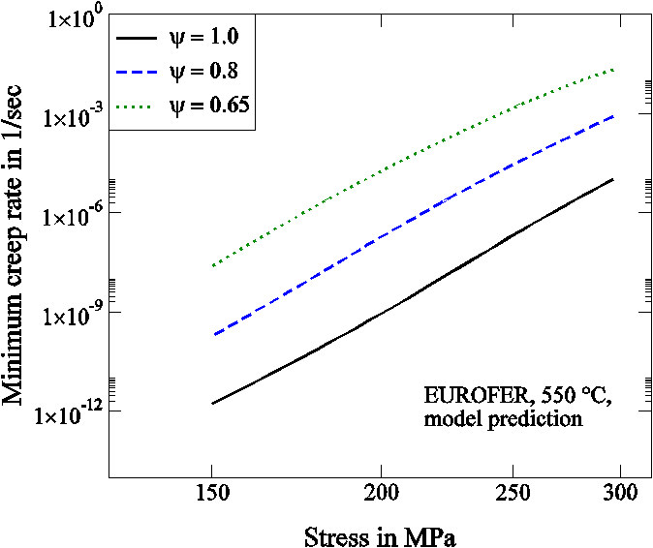 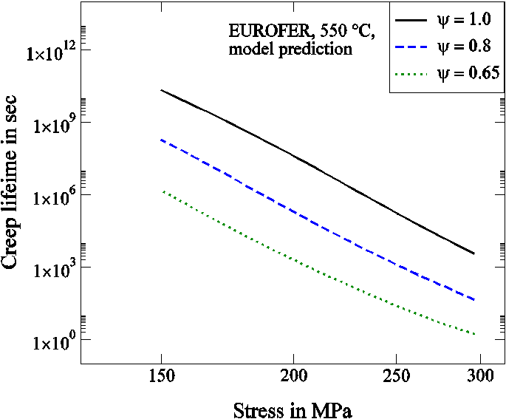

1. (b)

Figure 5: Impact of cyclic softening on minimum creep rate predicted using the coupled deformation-damage model developed for EUROFER (a) and on creep lifetime calculated applying the Monkman-Grant relationship (b).

Considering the $K_{ψ}$ approach the modification proposed for the creep-fatigue accumulation rule can be implemented in existing design codes by:

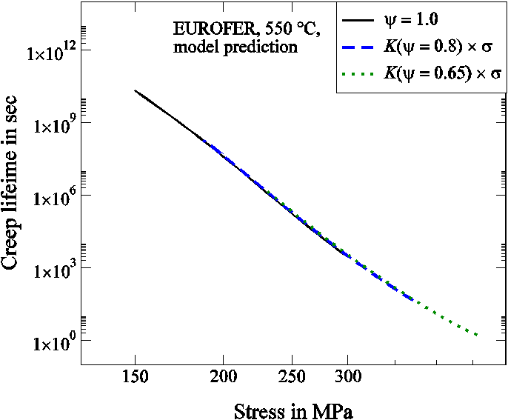

Figure 6: Shifted creep rupture time curves for cyclic softened EUROFER to that of cyclic un-softened EUROFER calculating the cyclic softening stress factor, $K_{ψ}$ for different cyclic softening levels.

1. Replacing the steps for calculating the creep portion of the total damage with the following:
2. For the first 10% of the design lifetime the initial stress, $S_{i}$ at the beginning of the hold time periods relevant for creep is determined from monotonic stress strain curves according to already existing rules. The relaxed stresses $S_{r}(t)$ within the hold time periods relevant for creep are determined either by using a proper constitutive model for relaxation or by direct reading from the isochronous stress strain curves. The allowable creep times for the stresses $S_{i}$ and $S_{r}(t)$ required for calculating the creep damage are determined as in already existing rules from the design creep curves of as received material assuming no effect of cyclic softening on stress-to-rupture curves
3. For the remaining 90% of the lifetime the initial stress, $S_{i,c}$ at the beginning of the hold time periods relevant for creep is determined from cyclic stress strain curves at the same strain previously considered for the determination of $S_{i}$. With the cycling softening level, $ψ=S_{i,c}/S_{i}$ the relaxed stresses $S_{r,c}(t)$ within the hold time periods relevant for creep are then determined to:



The allowable creep times for the stresses $S_{i,c}$ and $S_{r,c}(t)$ required for calculating the creep damage are determined as in already existing rules from the design creep curves of as received material at stresses equal to ${K_{ψ} S}_{i,c}$ and ${K_{ψ} S}_{r,c}(t)$, respectively, taking hence into account the effect of cyclic softening on creep rupture time.

1. Using the same creep fatigue interaction diagram for SS 316 in ASME-BVP and RCC-MRx codes for the determination of the allowable total creep fatigue damage values.

# Conclusion

The creep fatigue rules proposed for EUROFER based on proper modifications of the creep-fatigue accumulation rules of the ASME-BVP and RCC-MRx codes are further simplified by introducing the cyclic softening stress factor, $K_{ψ}$ approach with which the impact of cyclic softening on creep rupture time is considered. A draft for implementing the simplified modifications in the respective chapter of the DDC is given in addition. However the rules requires for their application $K_{ψ}$ as a function of the cyclic softening level, $ψ$ which shall be determined by evaluating the data of creep tests on pre-fatigued specimens. The planned tests of this type are currently in progress and their results so far back the approach pursued, particularly the independence of the Monkman-Grant relationship on cyclic softening.

# References

|  |  |
| --- | --- |
| [1] | J. Aktaa, „Creep-fatigue rules for EUROFER,“ EFDA_D_2 LDAFV, 2015. |
| [2] | J. Aktaa, „Creep tests on pre-fatigued specimens,“ EFDA_D_2LLS3S, 2015. |
| [3] | J. Aktaa, „Test specification EUROFER LCF long hold times,“ EFDA_D_2LJDNQ, v1.1, 2015. |
| [4] | J. Aktaa and R. Schmitt, “High temperature deformation and damage behavior of RAFM steels under low cycle fatigue loading: Experiments and modeling,” vol. 81, pp. 2221-2231, 2006. |
| [5] | J. Aktaa, „Creep-fatigue rules for EUROFER,“ EFDA_D_2L779C, 2014. |
| [6] | M. Rieth, M. Schirra, A. Falkenstein, P. Graf, S. Heger, H. Kempe, R. Lindau und H. Zimmermann, „EUROFER97 - Tensile, Charpy, Creep and Structural Tests,“ Scientific Report, FZKA 6911, Karlsruhe Institute of Technology, 2003. |
| [7] | G. Angella, „News about fatigue + creep tests on EUROFER,“ e-mail, Oct. 2016. |

1. One *Deliverable Report* shall be submitted for each deliverable e.g. Study Report, Commissioning Report, Final Assessment Report, Technical Acceptance Report, Procurement Report, etc.